Technological improvements and economies of scale are leading to larger and more efficient wind turbines. Offshore wind turbines are expected to reach 15-20 MW in rated power by 2030.

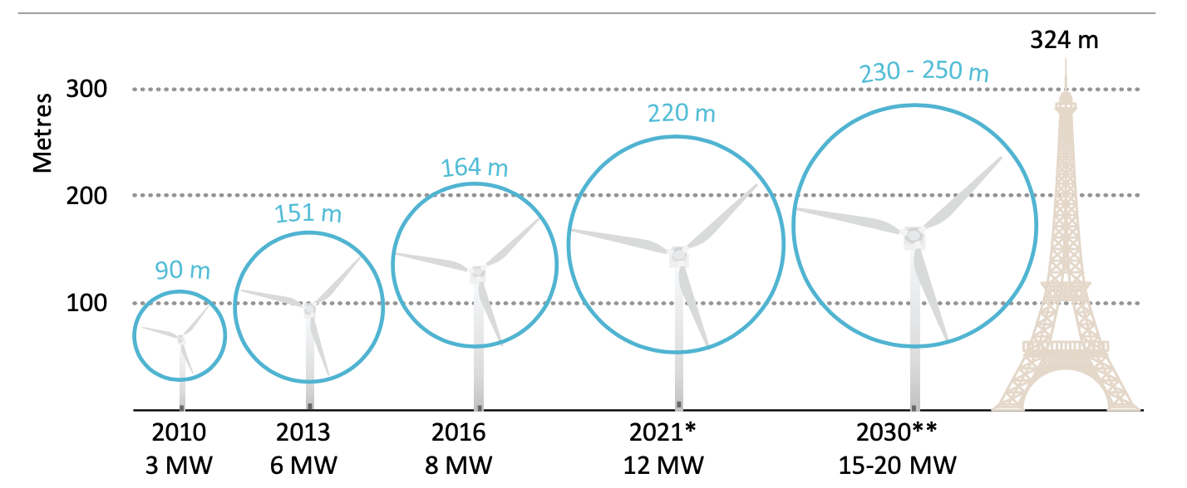

Evolution of the largest commercially available wind turbines. Retrieved from IEA’s Offshore Wind Outlook 2019.

While larger turbines improve performance and reduce overall costs, there are plenty of engineering challenges to overcome in design, validation, and manufacturing. Larger wind turbines are able to utilize increased wind speeds located higher in the atmosphere. There is a cubic relationship between power output and velocity, so if wind speeds are doubled, power output increases by a factor of 8. However, higher wind speeds and larger blades increase stress loads and vibrations on the wind turbine. Lighter and more flexible materials are needed to maintain structural integrity and to keep costs low.

Open source reference wind turbines (RWTs) have helped optimize and reduce potential risk of implementing larger turbines. RWTs increase engagement and allow public access for researchers to test new ideas on a benchmarked design. They enable increased collaboration between industry and academia, while simultaneously allowing original equipment manufacturers (OEMs) to protect their intellectual property.

The first major reference turbine was developed in 2005 by the National Renewable Energy Laboratory. The NREL offshore 5-MW baseline wind turbine has helped improve structural analysis, blade design, and aerodynamics of future wind turbines. This model is still used today in research for both onshore and offshore wind farms. Last year, researchers at Coventry University used the NREL 5-MW RWT to study alternative operational strategies for wind turbines in cold climates. They were able to decrease ice accumulation by 25-30% for each blade. This resulted in increased annual energy performance and reduced downtime while preventing structural damage to the wind turbine.

In 2013, the Technical University of Denmark (DTU) released a 10-MW RWT, which has had over one thousand users, and serves as a baseline to test new technologies. Researchers at the Norwegian University of Science and Technology recently used the 10-MW RWT to perform wake effect analysis on floating offshore wind turbines. Floating offshore wind is still a relatively new field that can benefit from research institutions using RWTs to improve various aspects of this technology. According to NREL, 58% of U.S. offshore wind resources are located in deep water where traditional monopiles are not feasible. Floating offshore wind costs will likely converge with fixed-bottom wind turbines in the future and be a large part of the U.S market. Research with RWTs can accelerate testing of new designs and help de-risk this emerging industry.
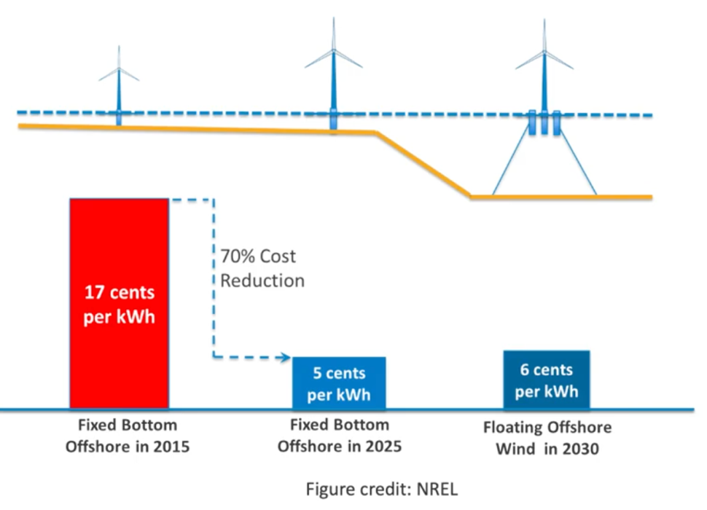

Synergies in supply chains will allow floating offshore costs to follow fixed-bottom trends. Retrieved from NREL’s Overview of Floating Offshore Wind.

As turbines continue to grow in size, RWTs need to keep up with any structural and technological changes. Larger turbines tend to have lower specific power, which is the ratio of a turbine’s generation capacity to its rotor-swept area. This allows turbines to capture a greater percentage of their rated power at lower wind speeds. Having higher capacity factors help improve grid integration as the wind turbines are less variable. However, larger rotors and nacelles come at the cost of additional weight and stresses on the turbine’s support structure. There has also been a shift from using traditional gearboxes to direct drive systems in order to reduce weight as well as improve performance and reliability. Direct drive generators have fewer moving parts and can generate electricity at lower speeds. Research projects funded by the Department of Energy are underway to make direct drive generators 50% lighter which could reduce turbine costs by 10-25%.

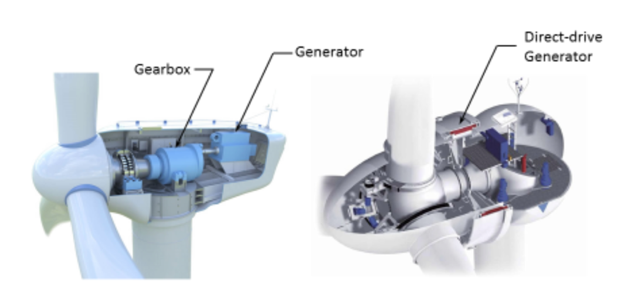
A wind turbine with a traditional gearbox (left) vs. a direct-drive generator (right).
Retrieved from Advanced Wind Turbine Drivetrain Trends and Opportunities.

Creating next-generation RWT models has been a worldwide effort. The International Energy Agency (IEA) has coordinated two new reference turbines through the IEA Wind Task 37. One RWT is a land based 3.4-MW design, which is optimized for low-wind speeds and aligns with currently available commercial wind turbines. Another, a 10-MW offshore turbine, is an updated and improved version of the aforementioned DTU 10-MW RWT. The shift in industry towards larger turbines has continued with GE recently commercializing the Haliade-X 12-MW. Siemens Gamesa has also launched a 14-MW offshore wind turbine with an industry leading 222-meter rotor diameter. To adequately capture and test the next generation of offshore wind turbines, the IEA released a 15-MW RWT earlier this year.

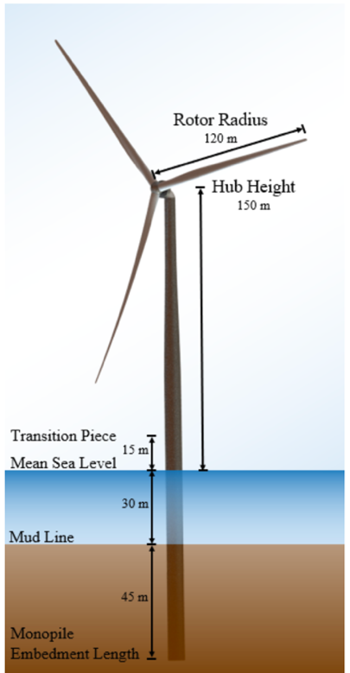

Dimensions of IEA’s 15 MW Reference Turbine.
Retrieved from NREL’s Definition of the IEA 15-Megawatt Offshore Reference Wind Turbine.

This 15-MW RWT is the result of a joint effort by NREL, DTU, and the University of Maine. The IEA 15-MW RWT will help accelerate the growth of larger turbines and allow researchers to examine and evaluate the performance of new technologies. These larger RWTs will allow researchers to more accurately portray the turbines that manufacturers such as GE and Siemens Gamesa will be producing in the next few years.

Competition between turbine manufacturers has sparked new innovations to deliver cost savings and performance improvements for wind farms. However, non-disclosure agreements to protect intellectual property can limit collaboration between researchers. To advance the offshore wind industry globally, it will be crucial to find an adequate balance to protect intellectual property, while still encouraging collaboration and sharing of relevant data.

There have been many efforts to increase collaboration in the offshore wind industry. In the United States, NREL and the National Offshore R&D Consortium are bringing together researchers, developers, and other stakeholders to accelerate cost saving measures. In the United Kingdom, the Offshore Renewable Energy Catapult has played a key role driving innovation in the U.K. and has supported hundreds of research programs since 2012. In Denmark, the Danish Research Consortium for Wind Energy connects multiple universities and institutes to strengthen and unite research efforts. One of the most recent successful joint industry partnerships is the PISA project led by Ørsted and Oxford University through the Carbon Trust’s Offshore Wind Accelerator Program. PISA stands for Pile Soil Analysis and looks to optimize and lower the costs of monopile installations. New research from this project suggests that steel usage in monopile foundations could be cut by 30 percent, reducing costs and improving the machines’ overall environmental footprint.

Open-source modeling has played an important role in helping standardize and de-risk key aspects in offshore wind. Continued use and support of reference wind turbines will enhance the synergistic relationships between industry and research communities. These partnerships will drive down the costs of offshore wind and help accelerate the clean energy transition.

IEA (2019), Offshore Wind Outlook 2019, IEA, Paris https://www.iea.org/reports/offshore-wind-outlook-2019
https://doi.org/10.1016/j.renene.2019.08.023
https://iopscience.iop.org/article/10.1088/1742-6596/1356/1/012004/pdf
https://www.nrel.gov/news/program/2020/floating-offshore-wind-rises.html
https://emp.lbl.gov/specific-power#:~:text=What%20is%20Specific%20Power%3F,net%20capacity%20factor%20(NCF).
https://www.energy.gov/eere/articles/advanced-wind-turbine-drivetrain-trends-and-opportunities
https://www.energy.gov/eere/articles/department-energy-selects-projects-develop-high-efficiency-lightweight-wind-turbine
https://www.siemensgamesa.com/en-int/newsroom/2020/05/200519-siemens-gamesa-turbine-14-222-dd

