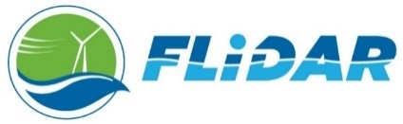

Document Number: ATI-RfQ-001 Issue Date: September 10, 2018
Contact: Marylandrfq@axys.com Closing Date: October 15th, 2018 23:59 PST
Request for qualification: FLIDAR offshore operation support
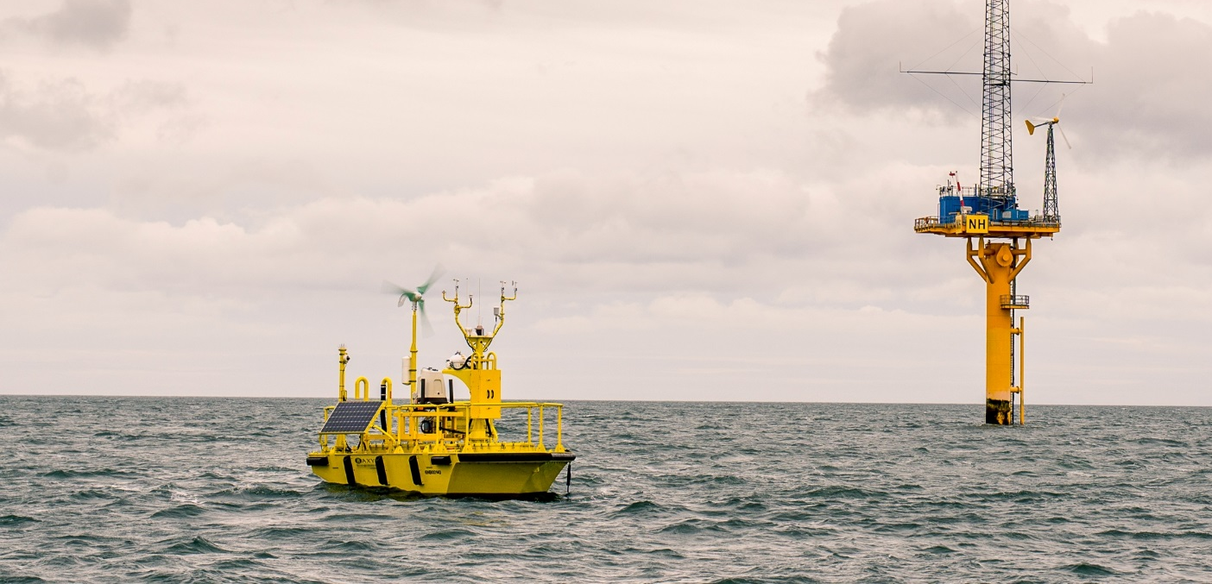Prepared by
AXYS Technologies
Head Office | European Office
2045 Mills Road | Esplanadestraat 1
Sidney, British Columbia | 8400 Oostende
Canada | Belgium
www.axystechnologies.com

Contents
1. Background 1
2. Seeking Maryland Providers 1
3. Request for Qualifications Process 2
4. Services Needed and Minimum Requirements 4
5. General Summary 6

Background
AXYS Technologies, Inc. (AXYS) has more than forty years of experience as a world leader in remote environmental monitoring. Our FLiDAR WindSentinel buoys are used by offshore wind farm developers to assess the wind resource needed to determine the energy potential of their wind farm site. These are multi-year projects, with often several projects in a region going concurrently. AXYS owns and operates the buoys and the data network, providing a full turnkey solution that is suitable for harsh environments.
For each geographic area that AXYS operates in, we build a network of local suppliers who can provide one-off or ongoing support for our onshore and offshore activities. We look to work with reliable solution partners who are interested in the opportunity to enter the offshore wind market at its early stages.

Seeking Maryland Providers
AXYS is looking to expand our existing supplier network with additional qualified suppliers able to support an upcoming floating LiDAR measurement campaign with Maryland In-State expenditures (see 3C for definition). The AXYS FLiDAR WindSentinel will be deployed to a location northeast of Ocean City’s coastline for at least a year starting around January 2019, with local preparation activities to begin in October. To support our FLiDAR campaign, we are seeking a variety of services:
- Vessel providers to support our floating LiDAR operations, primarily deployment and recovery of the FLiDAR WindSentinel and its mooring, or the transport of personnel for transfer at sea;
- Port-side equipment for managing the FLiDAR WindSentinel, including but not limited to cranes, stairs, forklifts will need to be rented at a port convenient to the project location;
- Operation coordination to aid with local project coordination of vessels, port space, equipment and personnel;
- Mooring support in the form of mooring design review, component sourcing and certification;
- Onshore field technicians with current applicable H&S qualifications that could be trained to support onshore commissioning, decommissioning, maintenance and repair port-side;
- Offshore field technicians with current applicable H&S qualifications and experienced with offshore deployment and recovery and/or maintenance at sea;
- Logistics and storage to support the transportation of the FLiDAR WindSentinel and coordination for receipt and pick-up of goods, deliver parts to site, and provide a storage space for spare parts inventory and tools for the duration of the project; and,
- Emergency response includes both emergency response vessels and equipment providers familiar with BOEM Oil Spill Response Plan.

The purpose of this Request for Qualifications (RfQ) is to determine if there are adequate qualified providers that could support AXYS’ floating LiDAR measurement campaign.
Based on the review of the RfQ Responses AXYS may issue a direct award for services or may follow with a Request for Proposals to qualified respondents. AXYS may issue one or multiple contract(s) for provision of the services but is under no obligation to do so.

Request for Qualifications Process
Respondents
Organizations or individuals meeting the mandatory requirements are invited to provide a response to AXYS which evidences how they meet the required and desired criteria.

Final responses should be emailed to marylandrfq@axys.com by October 15th, 2018 23:59 PST and should include the words “MARYLAND RFQ – [Your Company Name]” in the subject line.
Deadline
Responses should be submitted electronically to marylandrfq@axys.com as soon as possible. AXYS will begin reviewing responses immediately on September 15th, 2018 and will continue the process until adequate responses are received, or until the work is assigned. Responses should be emailed by October 15th, 2018 23:59 PST to be considered for the first round of work.
Response Outline
Interested parties are asked to prepare a short response that outlines the respondent’s qualifications to meet the requested scopes of work.
In your response, please provide the following information:
- Company description – include name of business, primary contact information, legal structure, number of employees, years in business
- Disadvantaged Business Category—please identify if any disadvantaged business category applies (woman/minority/veteran owned) and whether the company is registered as such in Maryland
- In-State Expenditure – “in-State expenditure” means either (i) a payment for work that is physically performed in the State of Maryland or (ii) a payment to a business that (a) is registered to do business in Maryland, or (b) has a tax domicile in Maryland. Please confirm whether the company has a Maryland presence, and the specific details of that presence (legal entity incorporated in Maryland, tax domicile, physical location, headquarters, solo location, etc.). Please also identify the number of employees physically located in Maryland and/or the amount of work that will be performed in the State of Maryland.
- Identify which categories you are responding to provide services (multiple entries are encouraged):
  - Vessel providers
  - Port side equipment
  - Operation coordination
  - Mooring support
  - Onshore field technicians/Engineers
  - Offshore field technicians
  - Logistics and/or storage
  - Emergency response

- Provide specifics about your offered services and how they meet the minimum requirements listed in Section 4, along with the additional specifics requested below
  - For vessels, please also provide vessel specifications, rate schedules, and any known black-out dates and which ports in Maryland that you muster from
  - For port-side equipment, also provide lists of available equipment (including recent certifications/inspections) and rate schedules and which ports in Maryland you can serve
  - For coordination services, or personnel for technical or offshore activities, or port-side services (e.g. welding), or mooring support, please provide example bios/resumes, training certificates and rate schedules
- Summarize years of experience with the type of services specified in the RfQ and list references, other project examples, or other evidence of proven capacity to deliver the services
- Provide supporting brochures/specification sheets, sample reports or other relevant materials as evidence of the services offered
- Provide evidence of certifications, registry, IMCA audits, etc. as appropriate for the service offered
- Provide your company’s current HSE policy and HSE stats for the last three years

Enquiries
All questions related to this RfQ should be sent electronically to marylandrfq@axys.com as soon as possible to allow AXYS time to respond. Estimated response time is 48 hours.
Review and Selection
Responses not meeting all mandatory criteria will be rejected without further consideration. Respondents that do meet all the mandatory criteria will be contacted by AXYS for further review. AXYS may issue a subsequent request for bids/proposals to qualified respondents, or AXYS may choose to direct award to potential respondents at its discretion.
Respondent Expenses
Respondents are solely responsible for their own expenses in preparing a response and for subsequent negotiations with AXYS, if any. AXYS will not be liable to any respondent for any claims, whether for costs or damages incurred by the respondent in preparing the response, loss of anticipated profit in connection with any final contract, or any other matter whatsoever.
Acceptance of Responses
This RfQ is not an agreement to purchase goods or services. AXYS is not bound to enter into a Contract with any qualified respondent. Responses will be assessed considering the qualification review criteria and need. AXYS will be under no obligation to receive further information, whether written or oral, from any Respondent.
Confidentiality and Non-Disclosure Agreement
The names of the respondents and specific information from qualified respondents to this RfQ will be shared with AXYS’ client for the FLiDAR campaign, but otherwise specific rates and related information will be kept private, except where it is already in the public domain. Once qualified applicants are identified, AXYS may request the respondent to first sign a non-disclosure agreement before proceeding to further discussions.
Definition of Contract
Notice in writing to a respondent that it has been identified as a qualified respondent will not constitute a contract nor give the respondent any legal or equitable rights or privileges relative to the service requirements set out in this RfQ or in any subsequent RfP. Only if a qualified respondent and AXYS enter into a subsequent full written contract, as a result of an RfP, will a respondent acquire any legal or equitable rights or privileges.

Services Needed and Minimum Requirements
Below is a general description of the flow of the project and services required, along with a high-level description of the minimum requirements. More specific descriptions will be provided to respondents who are selected to participate in subsequent discussions.
Qualified respondents who become contractors may perform and become responsible for one or more of the following services and duties.
- Coordination of transportation of the FLiDAR WindSentinel and/or other items required for the project from within and outside the US depending on the part to be transported to the project location;
- Sourcing of mooring components from US providers, third party review of mooring design, certification of mooring components;
- Technical support from commissioning the buoy to deployment-ready status;
- Deployment of the FLiDAR WindSentinel from port to a deployment location approximately 17 nautical miles northeast of Ocean City’s coastline;
- Lifting of the FLiDAR WindSentinel from port to vessel, vessel to deployment location and the reverse;
- One or two trips annually to the FLiDAR WindSentinel to enable AXYS to perform maintenance activities such as cleaning or parts replacement, conducted either at sea or port-side following a recover of the FLiDAR WindSentinel;
- Recovery of the FLiDAR WindSentinel from its deployment location approximately 17 nautical miles northeast of Ocean City’s coastline to port for maintenance or final recovery;
- Decommissioning of the FLiDAR WindSentinel and packaging for shipment;
- Shipment to its next destination; and,
- Stand-by Emergency recovery services which will be outlined in an Emergency Response Plan.

Please note that risk assessments, method statements, work plans and emergency response plans will be provided by AXYS and that in most cases an AXYS personnel will participate in all operations.
A technical summary of the AXYS FLiDAR WindSentinel specifications is outlined in Table 1 below. More information can be requested if required to put together the Response. Depending on the nature of the information requested AXYS may request the Respondent to first sign a non-disclosure agreement.

Hull construction | Welded aluminum. Four water tight compartments for electronics, power and sensors. Aluminum superstructure and stainless-steel substructure.
Finish | Marine grade epoxy yellow paint.
Dimensions | 6m (L) x 3.2m (W) x 9m (H).
Weight (excluding mooring and ballast) | 6500 kg.
Mooring and ballast | Inverse catenary, chain, semi-taught or false bottom. 5000 kg mooring and ballast.
Position | GPS package monitors whether buoy is on position.
Power | Primary batteries, solar & turbine supplemented with onboard generator.
Table 1: FLIDAR WindSentinel Specifications

To support these project needs, providers of services need to be able to meet these minimum standards to be considered:

Service Area | Minimum Requirements
For all Respondents | - Health, Safety and Environment policies and statistics  - Legal entity in good standing, or in the case of individual respondents, meets mandatory legal requirements for work in the US
Vessels – primary, | - 20T tow winch minimum / secondary tugger winch  - A-Frame and or crane 20T capacity  - Roller on the Stern  - 50’+ useable deck space  - IMCA certified (or equivalent)  - 80-foot vessel (recommended but not required if all other requirements have been met)  - (preferred) low freeboard
Vessels - Support / Auxiliary vessels | - RHIB 25’ + with 10 ton rated tow bollard or equivalent tow point  - Rigid hull crew transfer vessels with 10 ton rated tow point(s)  - Able to work at 20 nm out for 10-12 hours minimum period
Port-side Equipment Providers | - Cranes with lifting capacity of 20 tons+ for lifting the buoy off and on quay side and to complete compass calibrations  - Rolling safety stairs with gate to access buoy deck on shore  - Forklift or small crane to support installation of heavier sensors – 1100 lbs (500 kg) capacity  - Mobile office, lavatory facilities, waste bins / containers, emergency response equipment (fire extinguishers during on site work)
Port-Side Services | - Bio-fouling cleaning and disposal on recovery of buoys  - Fuel oil delivery – initial fill will require 264 gallons (1000 L)  - Welding services – for mooring assembly to weld shackles in place once loaded on the vessel and to cut shackles on recovered mooring  - Hazardous goods disposal (for engine fluids)  - Waste management – debris / recycling, engine fluids, use chain disposal / recycling
Mooring support | - Mooring design review experience  - Mooring component certification experience  - 3rd party mooring component sourcing to specifications that would be provided
Operations  Coordination | - Experience coordinating local port arrangements, equipment, etc.  - Experience chartering vessels  - Specific Personnel that could be dedicated to the project
Onshore field technicians/Engineers | - Skills in some or all of Electrical, Mechanical, Computers & Telemetry, Power systems (diesel, fuel cells, small wind turbines/solar)  - Build and/or maintenance/repair experience with integrated systems  - Working knowledge of remote sensing and instrumentation  - Experienced working outdoors/in field  - Industrial first aid  - Confined space training  - Working from heights training  - (optional) Welding experience  - (optional) Party Chief experience  - (preferred) technicians/engineers who are also qualified to go offshore
Offshore Technician Personnel Support | - Offshore experience  - Certifications in GWO or equivalent for first aid and Sea Survival  - Valid UKOG medical certificate or equivalent  - (preferred) transfer at sea experience  - (preferred) maintenance on small craft at sea experience  - (preferred) Mooring deployment/retrieval experience
Logistics | - Established relationships with logistics/expeditors in UK, US, Canada  - Experience moving goods through US customs and import processes
Storage | - Secure storage facility or controlled yard to store a 20’ container  - Located Port-side or near-coastal storage access  - (optional) Support services for inventory receipt and tracking  - (optional) Delivery services for inventory to port
Emergency Recovery | - Tow winch of 20 tons +  - Maneuverability to get in close enough to capture FLiDAR WindSentinel
Emergency Spill Response | - Prior experience as US Coast Guard’s OSRO certified organization to respond to potential at sea oil spills.  - Familiarity with BOEM Oil Spill Response Plan (OSRP) requirements

General Summary
AXYS is an equal opportunity employer and does not discriminate for employment or contracting based on gender, ethnicity, religion, sexual orientation or refugee/immigration status, so long as respondent meets the legal requirements to work in the US.
Quality, Health, Safety and Environment (QHSE) is important to AXYS, and all contractors will be expected to maintain appropriate QHSE standards and reporting. Contractors will agree to abide by all relevant laws and ethics appropriate to the contracted scope of work as a condition of the contract.
AXYS encourages all qualified companies to apply, and we look forward to receiving your responses. If you have questions, please direct those to marylandrfq@axys.com.

