**Ventus Awards Submission Directions**   
**Delete this page before submitting your nomination**

*Application materials must be submitted as a single PDF file via the online portal. Each page must include at the top 1) the entry category 2) nominated individual/company name 3) project title (as applicable) 4) and page number. Use 12-point Times New Roman font, single space. The Award Application submission should include:*

**Title page:** Include the **Nominated Name** (individual/company/organization);  **Nominated Project Name**; and **Project Location** (as applicable).  

**Nomination Overview:** Include the **Nominated Name** (individual/company/organization); **Nominating Name** (if different entity); **Submitting Individual/s** name, email; **Nominated Point of Contact/s** name, email; **Short Description** (75 words or less).*NOTE*: This description will provide the basis for all publicity for the nomination. 

**Executive Summary (max 500 words):** A brief overview of the project. Explain all factors that exhibit the project’s uniqueness and complexity, such as innovative engineering, challenges faced, and overall social impact.  

**Description (min 300 words | max 2,000 words):** Address the criteria for the category you are entering. Describe why this project is worthy of special recognition. Entrants may use text, photos, graphics, organizational charts as needed.  

**Overview (do not exceed 5 pages):**Showcase organizational information, project description/approach (including problem solved, if applicable), implementation strategy, results and outcomes, as well as outlines key participants/team members, owner/client (if applicable), and images. Access Submission Template here)  

**Images:**High resolution headshot or group photo and company logo (300 dpi). 

**Reference Letter:** (max 500 words). *Applicable only for Innovation of the Year, Advancement in Project Siting & Development, HSE Program of the Year, Next-Gen Leadership***.**   
A letter from theClient/Owner addressed to Ventus Awards Committee describing the relationship of the client/owner and entrant in the development of the project (note: can be the same entity), the project in use, and how the entrant’s contribution solves the client/owner’s needs.

*All applicants will be judged solely on their submitted materials*

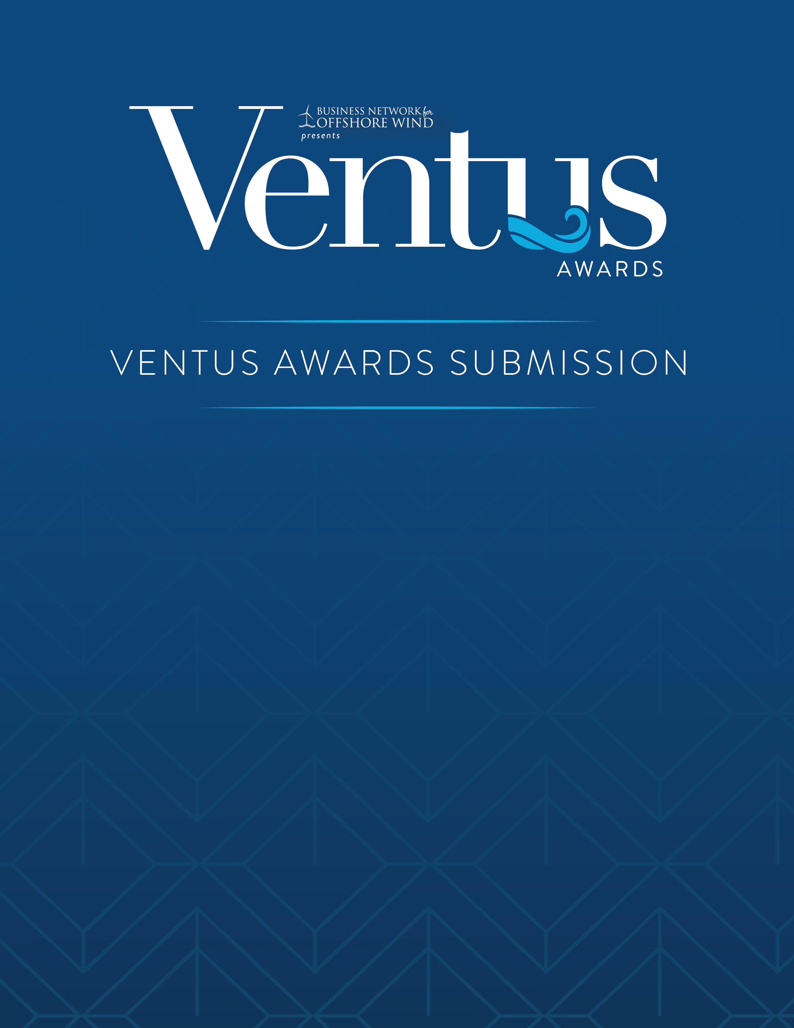

**NOMINATION OVERVIEW**

Nominated Name

**Nominated Project Name**

Project Location



Include the Nominated Name (individual/company/organization); Nominating Name (if different entity); Submitting Individual/s name, email; Nominated Point of Contact/s name, email; Nominated Description (75 words or less describing the individual/company/organization being nominated).*NOTE*: This description will provide the basis for all publicity for the nomination.

**EXECUTIVE SUMMARY**



Max 500 words. A brief overview of the project. Explain all factors that exhibit the project’s uniqueness and complexity, such as innovative engineering, challenges faced, and overall social impact.

**DESCRIPTION**



Minimum 300 words, maximum 2,000 words. Address the criteria for the category you are entering. Describe why this project is worthy of special recognition. Entrants may use text, photos, graphics, organizational charts as needed.

**OVERVIEW**



Do not exceed 5 pages. Showcase organizational information, project description/approach (including problem solved, if applicable), implementation strategy, results and outcomes, as well as outlines key participants/team members, owner/client (if applicable), and images.

**IMAGES**



High resolution headshot or group photo and company logo (300 dpi).

**REFERENCE LETTER**



*Max 500 words. Applicable only for Innovation of the Year, Advancement in Project Siting & Development, HSE Program of the Year, Next-Gen Leadership*   
   
Provide a letter from theClient/Owner addressed to Ventus Awards Committee describing the relationship of the client/owner and entrant in the development of the project (note: can be the same entity), the project in use, and how the entrant’s contribution solves the client/owner’s needs.