Ventus Awards Submission Directions
Delete this page before submitting your nomination
Application materials must be submitted as a single PDF file via the online portal. Each page must include at the top 1) the entry category 2) nominated individual/company name 3) project title (as applicable). Use 12-point Times New Roman font, single space and include a page number. The Award Application submission should include:

Title page: Include the Nominated Name (individual/company/organization); Nominated Project Name; and Project Location (as applicable).
Nomination Overview: Include the Nominated Name (individual/company/organization); Nominating Name (if different entity); Submitting Individual/s name, email; Nominated Point of Contact/s name, email; Short Description (75 words or less). NOTE: This description will provide the basis for all publicity for the nomination.
Executive Summary (max 500 words): A brief overview of the project. Explain all factors that exhibit the project’s uniqueness and complexity, such as innovative engineering, challenges faced, and overall social impact.
Description (min 300 words | max 2,000 words): Address the criteria for the category you are entering. Describe why this project is worthy of special recognition. Entrants may use text, photos, graphics, organizational charts as needed.
Overview (do not exceed 5 pages): Showcase organizational information, project description/approach (including problem solved, if applicable), implementation strategy, results and outcomes, as well as outlines key participants/team members, owner/client (if applicable), and images. Access Submission Template here)
Images: High resolution headshot or group photo and company logo (300 dpi).
Reference Letter: (max 500 words). Applicable only for Innovation of the Year, Advancement in Project Siting & Development, HSE Program of the Year, Next-Gen Leadership.
A letter from the Client/Owner addressed to Ventus Awards Committee describing the relationship of the client/owner and entrant in the development of the project (note: can be the same entity), the project in use, and how the entrant’s contribution solves the client/owner’s needs.

All applicants will be judged solely on their submitted materials

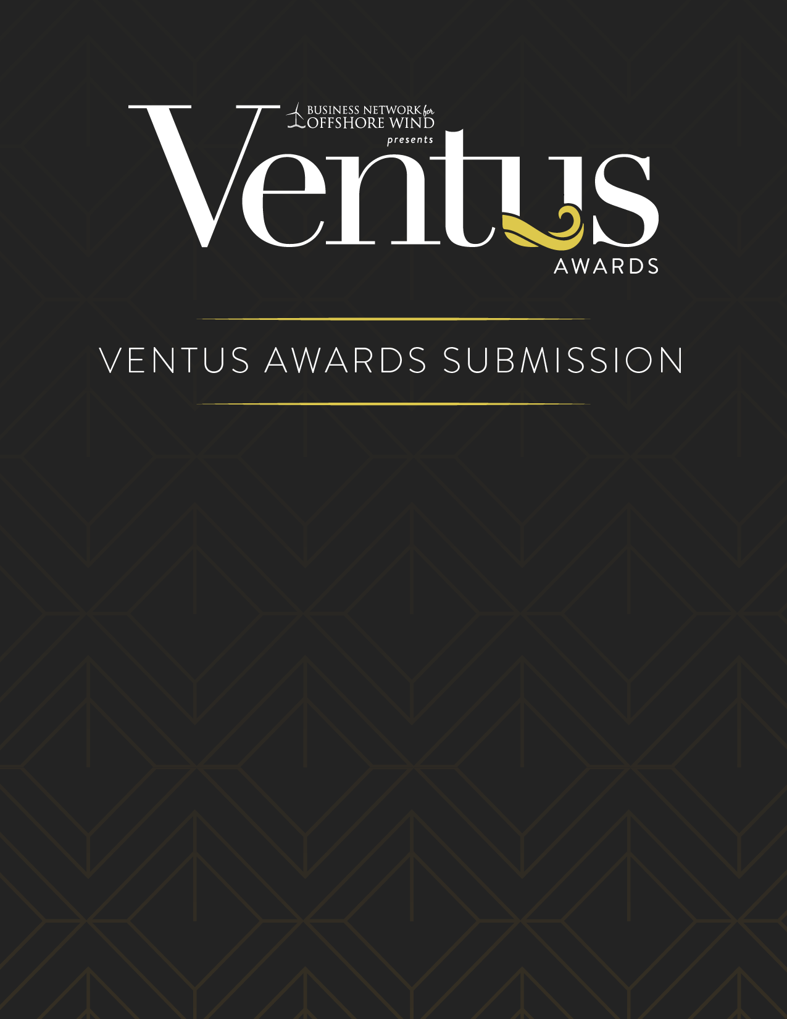

NOMINATION OVERVIEW
Nominated Name
Nominated Project Name
Project Location
Include the Nominated Name (individual/company/organization); Nominating Name (if different entity); Submitting Individual/s name, email; Nominated Point of Contact/s name, email; Nominated Description (75 words or less describing the individual/company/organization being nominated). NOTE: This description will provide the basis for all publicity for the nomination.

Example)
Nominated Name: Offshore Technologies
Nominated Point of Contact: John Smith, john@sample.com, 555-555-5555
Nominating Name: Brazil Wind Coalition
Nominating Point of Contact: Jane Doe, Jane@sample.com, 555-555-5555

Description

EXECUTIVE SUMMARY
Max 500 words. A brief overview of the project. Explain all factors that exhibit the project’s uniqueness and complexity, such as innovative engineering, challenges faced, and overall social impact.

DESCRIPTION
Minimum 300 words, maximum 2,000 words. Address the criteria for the category you are entering. Describe why this project is worthy of special recognition. Entrants may use text, photos, graphics, organizational charts as needed.

OVERVIEW
Do not exceed 5 pages. Showcase organizational information, project description/approach (including problem solved, if applicable), implementation strategy, results and outcomes, as well as outlines key participants/team members, owner/client (if applicable), and images.

IMAGES
High resolution headshot or group photo and company logo (300 dpi).

REFERENCE LETTER
Max 500 words. Applicable only for Innovation of the Year, Advancement in Project Siting & Development, HSE Program of the Year, Next-Gen Leadership
Provide a letter from the Client/Owner addressed to Ventus Awards Committee describing the relationship of the client/owner and entrant in the development of the project (note: can be the same entity), the project in use, and how the entrant’s contribution solves the client/owner’s needs.

